Gauss’ Law of Magnetism- Integral Form
Gauss’ Law of magnetism is one of the four fundamental laws of classical electromagnetism, collectively known as Maxwell’s Equations. Gauss’ Law of magnetism emerges from the “flux density” interpretation of the magnetic field.
Gauss’ Law of magnetism states that the flux of the magnetic field through a closed surface is zero.
This is expressed mathematically as follows:
∮_{S}B⋅ds=0 ………….(1)
where B is magnetic flux density and s is a closed surface with outward-pointing differential surface normal ds. It may be useful to consider the units. B has units of Wb/m²; therefore, integrating B over a surface gives a quantity with units of Weber (Wb), which is magnetic flux, as indicated above.
Gauss’ Law of magnetism can also be interpreted in terms of magnetic field lines. For the magnetic flux through a closed surface to be zero, every field line entering the volume enclosed by s must also exit this volume – field lines may not begin or end within the volume. The only way this can be true for every possible surface s is if magnetic field lines always form closed loops. This is in fact what we find in practice, as shown in Figure.
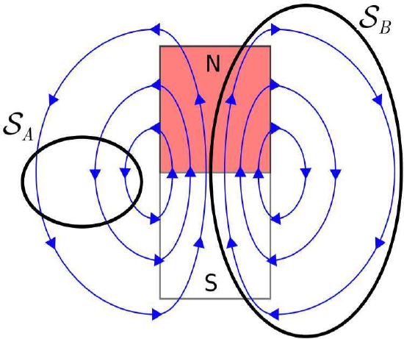
Figure: Gauss’ Law for Magnetostatics applied to a two-dimensional bar magnet. For the surface S=S_{A}, every field line entering S also leaves S, so the flux through S is zero. For the surface S=S_{B}, every field line within S remains in S, so the flux through S is again zero.
Following this argument one step further, Gauss’ Law of magnetism implies there can be no particular particle or structure that can be the source of the magnetic field (because then that would be a start point for field lines). This is one way in which the magnetic field is very different from the electrostatic field, for which every field line begins at a charged particle. So, when we say that current (for example) is the source of the magnetic field, we mean only that the field coexists with current, and not that the magnetic field is somehow attached to the current. Summarizing, there is no “localizable” quantity, analogous to charge for electric fields, associated with magnetic fields.
Thus, Gauss’ Law for Magnetic Fields requires that magnetic field lines form closed loops. Furthermore, there is no particle that can be identified as the source of the magnetic field.

Gauss’ Law of Magnetism- Differential Form

The equation may be obtained from Equation (1) using the Divergence Theorem, which in the present case may be written:
∫_{V} (∇⋅B) dv = ∮_{S} B⋅ds …….. (2)
Where V is the mathematical volume bounded by the closed surface S. From Equation (1) we see that the right hand side of the equation is zero, leaving:
∫_{V} (∇⋅B) dv = 0 …………(3)
The above relationship must hold regardless of the specific location or shape of V. The only way this is possible is if the integrand is everywhere equal to zero. We conclude:
∇⋅B = 0 …………(4)
The differential (“point”) form of Gauss’ Law for Magnetic Fields (Equation 4) states that the flux per unit volume of the magnetic field is always zero.
This is another way of saying that there is no point in space that can be considered to be the source of the magnetic field, for if it were, then the total flux through a bounding surface would be greater than zero.

